
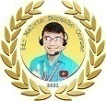
SESSION 3.2: SIR MELVIN BURACHO REVIEW CENTER (MAY 28, 2026)
GENERAL EDUCATION
(English)
https://www.facebook.com/share/v/1B6DrGFrRJ/

What error is committed in the sentence: I was tired I went to sleep.
- run-on
- faulty parallelism
- dangling modifier
- comma splice
I was tired, so I went to sleep.
Ex: I was tired (___) I went to sleep.
- A run-on sentence occurs when two independent clauses (complete thoughts) are joined together without any punctuation or coordinating conjunctions.
I was tired; I went to sleep.
Ex: I was tired, I went to sleep.
- A comma splice occurs when you join two independent clauses (complete sentences) together with only a comma.
My hobbies include reading, writing, and analyzing literature.
Ex: My hobbies include reading, writing, and to analyze literature.
- Faulty parallelism occurs when a sentence mixes different grammatical forms in a series, list, or comparison.
I found a woman’s silver bracelet.
Ex: I found a silver woman’s bracelet.
- A misplaced modifier occurs when a descriptive word or phrase is placed too far away from the word it is supposed to describe. Because of its bad position, it unintentionally describes the wrong word, often making the sentence sound ridiculous.
I told my brother I would play with him when the class was over.
When the class was over, I told my brother I would play with him.

Ex: I told my brother when the class was over I would play with him.
- A squinting modifier is a very specific type of misplaced modifier. It happens when a descriptive phrase is placed right in the middle of two actions, making it look both left and right. Because it sits in the middle, the reader cannot tell which action it is supposed to describe.
After finishing the homework, I turned on the TV.
Ex: After finishing the homework, the TV was turned on.
- A dangling modifier occurs when a descriptive phrase is included in a sentence, but the person or thing doing the action is completely missing from the sentence.

To show phonological awareness skill in____________, the student says the word, then says the syllable or sound.
- Counting
- Segmenting
- Rhyming
- discriminating

- Counting in phonological awareness involves tracking the number of words in a sentence, or the number of syllables/sounds in a word.

- Segmenting is the ability to break a whole word down into its individual parts, such as its syllables or individual sounds (phonemes).

- Rhyming is identifying or producing words that have matching ending sounds.

- Sound discrimination involves recognizing whether two sounds or words are the same or different.

FIGURES OF SPEECH
Figure of Speech | Definition | Example
Simile   |     An indirect comparison that explicitly uses the words 'as' or 'like'. | She is as brave as a lion. / He runs like the wind.
Metaphor   |         A direct comparison between two unrelated things without using 'as' or 'like'. | Time is a thief. / You are my sunshine.
  Personification | 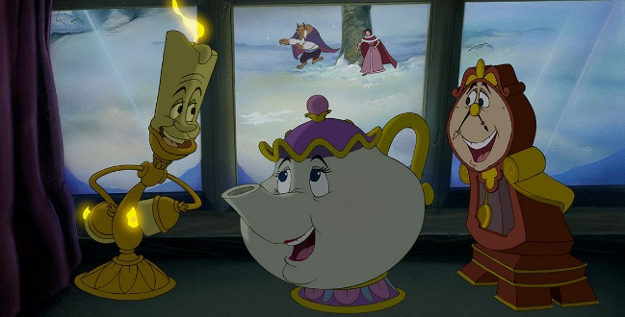  Giving human qualities, feelings, or actions to non-human things or objects. | The wind whispered through the trees.
  Litotes |       An understatement using a negative statement to express a positive meaning.     | You are not bad. (meaning you are quite good)
Apostrophe  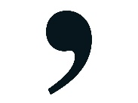 |   Directly addressing an absent person, abstract idea, or object as if it were present.  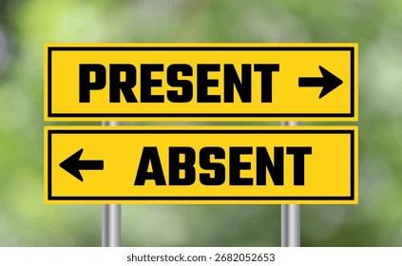 | O Death, where is thy sting?
  Allusion   |   An indirect reference to a well-known person, place, event, or literary work. | She is the Helen in our group. (referencing Helen of Troy)
  Hyperbole     | 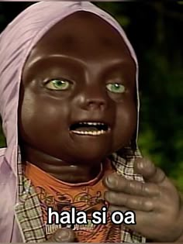  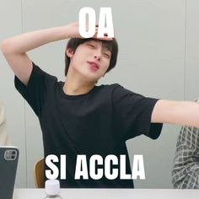  An extreme exaggeration used for emphasis, not meant to be taken literally. | I've told you a million times to clean your room!
Irony   |     A situation where the actual outcome is the opposite of what is logically expected. | A fire station burning down.
Synecdoche   | A figure of speech based on a part-to-whole (or whole-to-part) relationship.  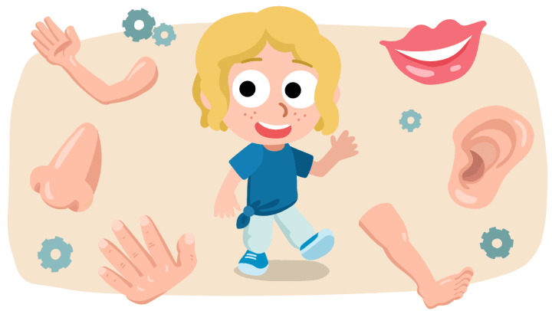 | All hands on deck. (hands = crew members)
  Metonymy | 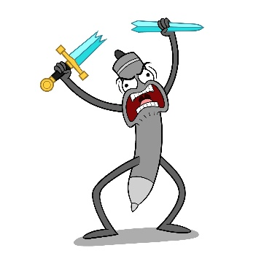  Replacing a word or concept with something closely related to it.  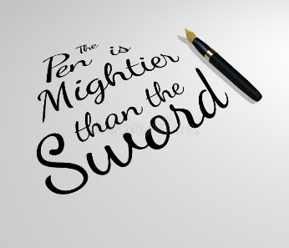 | The pen is mightier than the sword. (pen = written word)
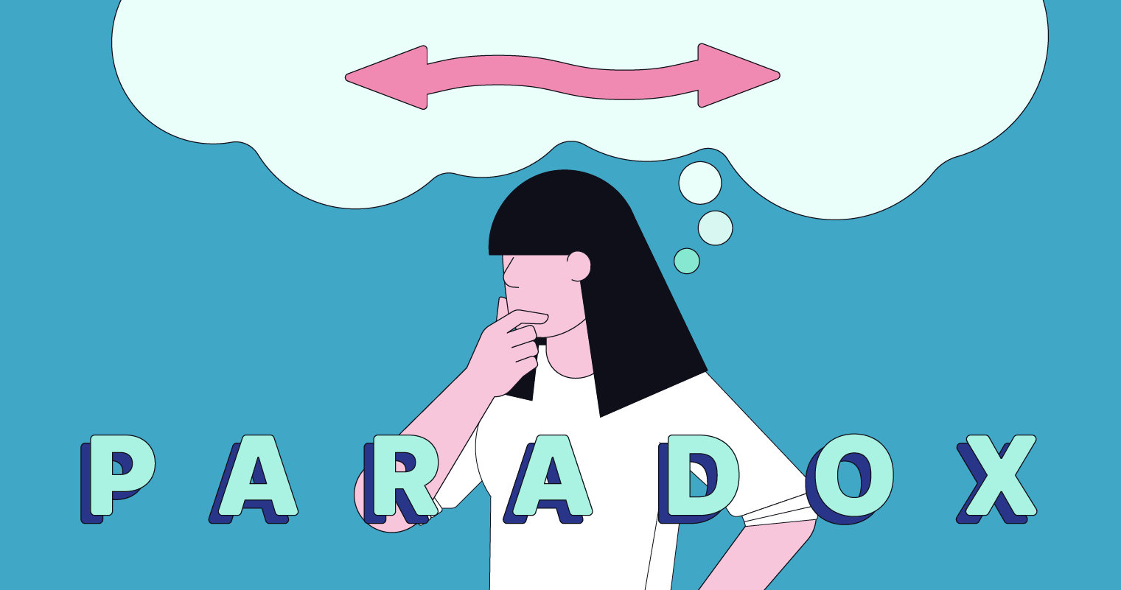  Paradox | 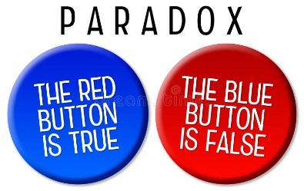  A statement that seems self-contradictory but reveals a deeper truth.   | The only constant in life is change.
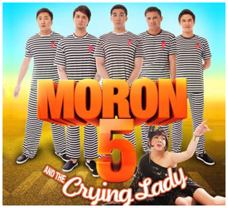  Oxymoron |   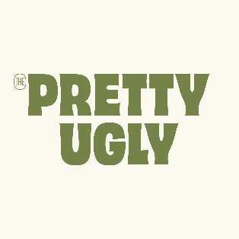  Two contradictory or opposite terms placed directly side by side. | Cruel kindness, Open secret, Deafening silence
Bathos   |     A sudden shift from a serious or lofty tone to something trivial or ridiculous. | He spent his final hour of life doing what he loved most: arguing with his wife.
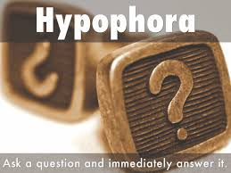  Hypophora |   A figure of speech where a speaker raises a question and then immediately answers it themselves. | Nagtanong ka tapos sinagot mo rin agad. (e.g., Should we give up? Absolutely not.)
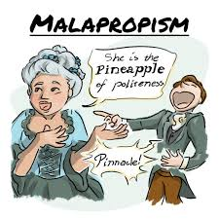  Malapropism |   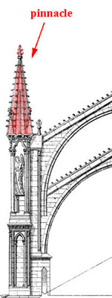  The mistaken use of an incorrect word in place of a similar-sounding word, often with an amusing result. | He's the pineapple of politeness. (instead of pinnacle)
  Spoonerism | 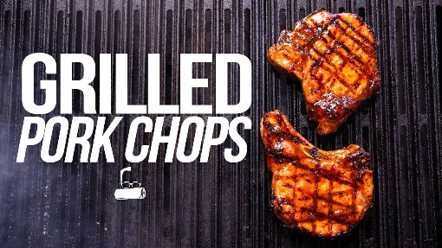  An error in speech where the initial sounds of two or more words are switched. | I love chork pop. Belly jeans (instead of pork chop, jelly beans)
  Rhetorical Question |   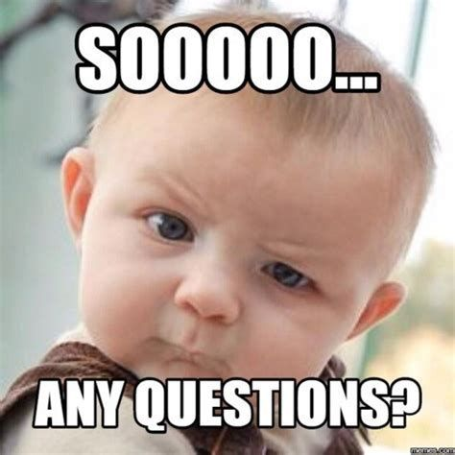  A question asked merely for effect or to make a point, with no answer expected. | A question that doesn't need an answer. (e.g., Are you crazy?)
Understatement   | Presenting something as less important, smaller, or less urgent than it actually is.  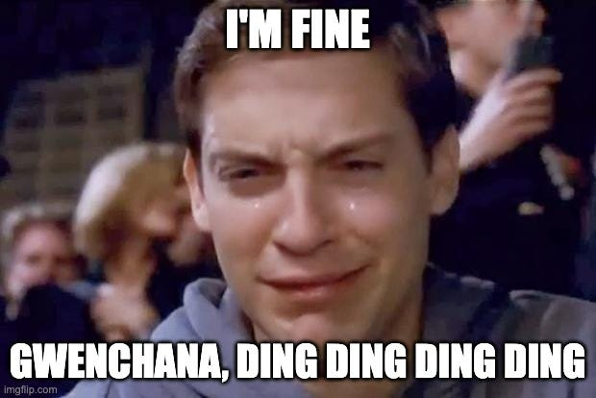 | Less than it is. (e.g., It's just a scratch when the car is totaled).
  Euphemism |   A mild, indirect, or pleasant word used to substitute for an unpleasant, harsh, or offensive one. | Your dog has gone to a better place. (instead of saying it died)
  Dysphemism |   A harsh, blunt, or offensive word used instead of a neutral or mild one. | Your dog died. or Croaked (the opposite of a euphemism)

What figure of speech is used in this line from Alvero’s poem? “Could God’s refuse / such tempting wine?”
- Apostrophe
- rhetorical question
- allusion
- metaphor

He runs faster than the speed of light.
- Simile
- Metaphor
- Hyperbole
- litotes

In Romeo and Juliet, by William Shakespeare, after being mortally wounded, Mercutio says, “Ay, ay, a scratch, a scratch; marry, ’tis enough.”
- Apostrophe
- Euphemism
- Understatement
- rhetorical question

Where are the human vocal cords located?
- Pharynx
- Esophagus
- Larynx
- resonator

- Resonators: amplify and modify the raw, buzzy vibrations (nasal cavity/ nose, oral cavity/ mouth, pharynx/ throat)

Which among the sounds below is voiceless?
- /b/
- /z/
- /v/
- /p/

- As you pronounce a letter, making a sound, feel for the vibration of your vocal cords. If you feel a vibration, the sound is a voiced one. If you do not, it is unvoiced/voiceless.

- There are 44 voiced sounds.

POETIC FEET

Poetic Foot | Pattern | Syllable Count | Examples | Simple Visual Memory Trick
IAMB | * / | 2 Syllables | a-bove, de-fend, to-day | Unstressed to Stressed (da-DUM)
TROCHEE | / * | 2 Syllables | mar-ket, ti-ger, da-ly | Stressed to Unstressed (DUM-da)
ANAPEST | * * / | 3 Syllables | un-der-stand, con-tra-dict | Two Unstressed to One Stressed (da-da-DUM)
DACTYLIC | / * * | 3 Syllables | po-e-try, bi-cy-cle, fa-mous-ly | One Stressed to Two Unstressed (DUM-da-da)
SPONDEE | / / | 2 Syllables | heart-break, bad news, shut up | Both Stressed (DUM-DUM)
PYRRHIC | * * | 2 Syllables | "...of the..." / "...in a..." | Both Unstressed (da-da)

In English verse, a poetic foot having one stressed syllable followed by one unstressed syllable is _______.
- Trochee
- Iamb
- Dactylic
- Anapest

This is a Latin term for a narrative that starts not at the beginning of events but at some other critical point.
- linear plot
- hubris
- in medias res
- deus ex machina

- Linear Plot: A storytelling structure where events are told in strict chronological order (the exact order they happened in time, from beginning to middle to end).
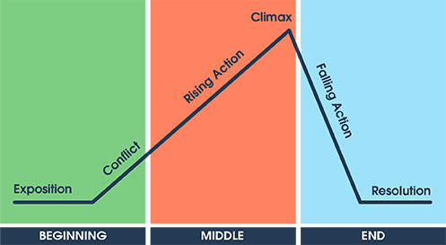

- Hubris: A Greek term referring to excessive pride or arrogance displayed by a character. This flaw often leads directly to their ultimate downfall (tragedy).

- In Medias Res: A Latin phrase translating literally to "in the midst of things" or "in the middle of things."

- Deus Ex Machina: A Latin phrase meaning "god from the machine." It describes a plot device where a seemingly unsolvable problem is suddenly and abruptly resolved by an unexpected, contrived, or highly improbable intervention (e.g., a character unexpectedly winning the lottery just as they face bankruptcy, or an alien ship randomly saving a hero at the last second).

Which order of words will result in a correct sentence?
- To change
- Significant power
- The nature of the world
- Man has acquired
- 3-2-1-4
- 2-4-1-3
- 4-1-2-3
- 4-2-1-3

There aren’t _____________ for everybody attending the meetings.
- enough chairs
- chairs enough
- much chairs
- enough of chairs

The sequence of events in a story is called _______.
- Conflict
- Setting
- point of view
- plot

- Conflict: The central struggle or problem between opposing forces that drives the story forward

- Setting: The specific time and geographic location in which the story takes place.

- Point of view: The perspective or angle from which the story is told

- Plot: The structured sequence of interconnected events that make up a narrative. It is the framework of what happens from the beginning, through the climax, to the resolution.

Maya wore the dress she loved despite the whispers behind her. In her village, everyone followed strict traditions, but she refused to conform.
- person vs person
- person vs self
- person vs society
- person vs nature

- Person vs person: A direct conflict between two individual characters.

- Person vs self: An internal struggle taking place within a character's own mind, usually involving a difficult choice, moral dilemma, or overcoming personal flaws.

- Person vs society: An external conflict where a character goes against the collective traditions, cultural beliefs, laws, or social expectations of a group or community.

- Person vs nature: An external struggle against natural forces, such as wild animals, extreme weather, survival scenarios, or diseases.

In a tragic drama, the hero’s downfall evokes strong feelings of pity and fear in the audience, resulting in an emotional release or purification at the end of the play. This emotional effect is known as _______.
- Catharsis
- Peripeteia
- Hamartia
- hubris

- Catharsis: An Aristotlean term describing the emotional release, cleansing, or purification experienced by the audience at the end of a tragedy. By witnessing the intense pity and fear on stage, the audience leaves feeling emotionally refreshed and balanced.

- Peripeteia: A sudden reversal of fortune or an unexpected turning point in a story, particularly in a tragedy where things pivot from good to catastrophically bad for the hero.

- Hamartia: The tragic hero's fatal flaw or error in judgment that inevitably sets their tragic downfall into motion (e.g., Romeo's impulsiveness).

- Hubris: A very specific and common type of hamartia, referring to excessive, blind pride or arrogance that causes a character to defy the gods or natural order.
______________________________________________________________________________

In third-person limited point of view, the narrator _______.
- knows only one character’s thoughts
- knows all characters’ thoughts
- is a character in the story
- talks directly to the reader

POINTS OF VIEW (POV)
Point of View | Pronouns Used | Narrator's Relationship to Story | Example Sentence
First Person | I, me, my, we, us | The narrator is a character in the story telling their own personal experience. | I walked into the classroom and felt my heart race.
Second Person | You, your | The narrator addresses the reader directly (common in guides, recipes, or choose-your-own-adventure books). | You walk into the classroom and feel your heart race.
Third Person: Limited | He, she, they, him, her | The narrator is an outsider who only knows the thoughts/feelings of one character. | She walked into the classroom, wondering if she would pass.
Third Person: Omniscient | He, she, they, him, her | The narrator is an outsider who is all-knowing and can see inside the minds of all characters. | She was nervous about the test, while he felt entirely confident.
Third Person: Objective | He, she, they, him, her | The narrator is an outsider acting like a camera crew; they only report actions and dialogue, with zero insight into anyone's thoughts. | She walked into the classroom and sat quietly at her desk.

Which traditional Japanese poem consisting of three lines totaling only seventeen syllables and treating the world in its natural setting is illustrated by the given verse?

Mellow, mild, May day,
Calling children out to play
summers on her way!
- by Patricia Cisco

- choka
- tanka
- renga
- haiku

- Choka: A traditional form of long Japanese poetry consisting of alternating lines of 5 and 7 syllables, ending with an extra line of 7 syllables. It has no fixed limit on the total number of lines.

- Tanka: A short five-line Japanese poem with a fixed syllable structure of 5-7-5-7-7, totaling 31 syllables. It is the older, parent form from which the haiku evolved.

- Renga: A collaborative or linked-verse Japanese poetic form where multiple poets alternate writing stanzas (typically alternating between 3-line and 2-line links) to build a long chain poem.

- Haiku: A short three-line Japanese poetic form with a strict 5-7-5 syllable pattern totaling 17 syllables. It traditionally requires a focus on a natural setting or season.

- Matsuo Bashō: Father of Haiku

He authored the popular short stories, “How My Brother Leon Brought Home a Wife, and “Midsummer’, which both depict scenes in Barrio Nagrebcan, Bauang, La union, where he was born.
- Manuel Arguilla
- Ismael Mallari
- Nick Joaquin
- Bienvenido Santos

- Manuel Arguilla: Arguilla is a renowned Ilokano writer best known for his short stories depicting rural life in Barrio Nagrebcan, Bauang, La Union, his actual birthplace. His famous works include "How My Brother Leon Brought Home a Wife" and "Midsummer", which capture the local color and romanticism of the Philippine countryside. (local color)

- Ismael Mallari: A prominent Filipino essayist and literary critic. He is best known for his autobiographical essays and his book "The Birth of Discontent", rather than local color short stories based in La Union. “Pliant Like a Bamboo”

- c. Nick Joaquin: One of the most celebrated Filipino writers, awarded National Artist for Literature. He wrote under the pen name Quijano de Manila. His works (like "The Woman Who Had Two Navels" and "May Day Eve") primarily focus on Spanish-colonial heritage, Catholic rituals, and Manila high society.

- d. Bienvenido Santos: A famous Filipino-American fictionist and poet. His stories (like "Scent of Apples") focus primarily on the lives, loneliness, and struggles of Filipino exiles and immigrants living in the United States.

“Only the heart can see rightly” this statement is lifted from what particular novel?
- The Prince and the Pauper
- The Little Prince
- The Right One
- The Pearl

- The Prince and the Pauper was written by Mark Twain or his real name Samuel Langhorne Clemens.

The Arabian folktale, “One thousand and One Nights”, is an example of which type of narrative structure?
- flash fiction story
- flashback story
- stream of consciousness story
- a story within a story

- Flash fiction story: An extremely short work of fiction, usually under 1,000 words (sometimes even fewer than 100 words), designed to tell a complete narrative in a tiny space.

- Flashback story: A narrative technique where the chronological timeline is interrupted to show an event that happened in the past, usually to give background context about a character.

- Stream of consciousness story: A modernist literary style that mimics the non-linear, chaotic, and continuous flow of a character's internal thoughts, feelings, and memories.

- A story within a story: Also known as a frame narrative, this structure features an overarching main story that sets the stage for a character to tell one or more sub-stories.

The Greek dramatist authored “Alcestis” and “Andromache”
- Homer
- Euripides
- Virgil
- Sophocles

- Homer: The legendary ancient Greek epic poet credited with composing the Iliad and the Odyssey.
- Euripides: He is one of the three great ancient Athenian tragedians. He authored both Alcestis and Andromache and is well-known for bringing greater psychological realism and strong female characters to classical Greek drama.
- Virgil: A classical Roman poet from the Augustan period. He is world-famous for composing the epic poem the Aeneid, which tells the legendary story of Aeneas fleeing Troy to eventually found Rome.
- Sophocles: Another giant of Greek tragic drama. His most famous works are the Theban plays, which include Oedipus Rex (Oedipus the King) and Antigone.

A story put together through an exchange of letter is called
- Fiction
- Episodic
- non-fiction
- epistolary

- Fiction: A broad category of literature that describes imaginary events, people, and stories rather than real facts. It is an umbrella term, not a specific format for letter-writing.

- Episodic: A narrative structure made up of a loose sequence of separate, self-contained chapters, installments, or episodes, rather than a single tightly woven plotline.

- Non-fiction: Prose writing that is based entirely on facts, real events, and real people, such as biographies, histories, and essays.

- Epistolary: Coming from the Greek word epistole (meaning letter), an epistolary novel is a story told entirely through documents like letters, diary entries, telegrams, or modern emails.

- Urbana at Feliza (fully titled Pagsusulatan ng Dalawang Binibini na si Urbana at si Feliza) by Padre Modesto de Castro is the most famous example of an epistolary work in Philippine literature.

Several factors must be assessed to arrive at a sound _________
- Query
- Decision
- Change
- Problem

The professor is an _____________ scholar whose discovery has had a lasting impact, and a major breakthrough in his research is _____________ within the next few months.
- imminent – eminent
- eminent – imminent
- eminent – eminent
- imminent- imminent

- Eminent: Famous, respected, distinguished, or prominent.

- Imminent : Incoming, About to happen, upcoming, or fast-approaching.

The Greek Goddess of War and Wisdom.
- Athena
- Minerva
- Ares
- Hera

GREEK AND ROMAN MYTHOLOGY
Greek Name | Roman Name | Domain / Description
Zeus | Jupiter | King of the gods; god of the sky, thunder, and lightning
Hera | Juno | Goddess of marriage
Poseidon | Neptune | God of the sea, earthquakes
Hades | Pluto | God of the underworld and the dead
Demeter | Ceres | Goddess of agriculture, grain, and fertility
Hestia | Vesta | Goddess of the hearth, home, and family
Athena | Minerva | Goddess of wisdom, war strategy, and crafts
Artemis | Diana | Goddess of the hunt, wilderness, and childbirth
Ares | Mars | God of war and violence
Aphrodite | Venus | Goddess of love, beauty, and desire
Hephaestus | Vulcan | God of fire, metalworking, and craftsmanship
Hermes | Mercury | Messenger of the gods; god of commerce and travel
Dionysus | Bacchus | God of wine, pleasure, and festivity
Eros | Cupid | God of love and attraction
Persephone | Proserpina | Goddess of spring and queen of the underworld

How do consonants differ from vowels?
- the method and place of articulation
- our mouth is always open in pronouncing consonants sounds
- the voicing of the words
- the obstacles in sound production

The ‘Dead Stars’ symbolizes___________.
- The love of Esperanza for Alfredo
- The love of Alfredo for Julia
- The love of Julia for Alfredo
- The love of Alfredo for Esperanza

- Paz Márquez-Benítez is the author of Dead Stars

‘I am a retired public school teacher. As a teacher, I was branded as a terror in school. The pupils dreaded the day they would enter my class. Little did they know that behind my unpopular facade was a heart full of compassion. But how did I earn this moniker? I did not tolerate dirty pupils in my class. I wanted them to know that cleanliness of body was good for their health. I inspected their teeth, nails, footwear, handkerchief, clothes, ears, noses and hair.’ The public school teacher gives much importance to her pupils’ _______.
- Cleanliness
- Absence
- Study
- Posture

The _______ of the story is to never give up.
- Morale
- Moral
- Morality
- Understanding

DRILLS

Context / Phrase | Answer / Meaning
Highness and lowness of your voice | pitch
The driver was found culpable for the accident. | guilty
Epi- means in epidermis | upon
The scammer took advantage of ----- people online. | credulous
Shilly shallying | hesitate
I don't like sonorous sounds. | loud
Yaya means (OD) | nursemaid
It's like a candle in the wind. | simile
Indian collection of fables | Panchatantra
Delivered the Gettysburg Address | Abraham Lincoln
It's a collection of stories first published in 1894, featuring famous characters like Mowgli. | The Jungle Book
A work of EAPoe about revenge and murder | Cask of Amontillado
"Ask not what your country can do for you – ask what you can do for your country." | John Kennedy
Medieval German epic | Nibelungenlied
Manila Film Festival was initiated by whom? | Antonio Villegas
Love sonnets | Edith Tiempo
To be or not to be | indecision
long narrative poem that tells the story of heroic deeds | epic
14 lines following a rhythmic pattern | sonnet
Poem for the dead | elegy
Message for the dead | eulogy
Somber/serious aspects of life ends unhappily | tragedy
Deals human folly and end happily | comedy
Literary genre that portrays rural life | pastoral
No meter and no rhyme | free verse
Humorous poems | limerick
Symbolic fictional account | allegory
Shakespeare's tragedy about two teenage star-crossed lovers | Romeo and Juliet
Becky Sharp is the main character of a book written by Thackeray | Vanity Fair
Wrote The Wedding Dance | Amador Daguio
Focus of literature during Hispanic Colonial Period | Christianity
Father of Horror and Detective Stories | Edgar Allan Poe
Part of newspaper where you can see opinions of the editorial board | Editorial
The Virgin is a work of | Kerima Tuvera
A poet who uses punctuation marks extensively in his pieces | Jose Garcia Villa
Theme of Rubaiyat | Grasp pleasure while you can
Collection of stories of animals which teach moral lessons | Aesop's Fables
Mercy is spontaneous and freely given | Merchant of Venice
Author of Invictus | William Ernest Henley
Poison Tree | William Blake
Magnificence | Estrella Alfon
People in the War/ The Visitation of the Gods/ The Butcher, The Baker, The Candlestick Maker | Gilda Cordero Fernando
The Woman Who Had Two Navels/ Summer Solstice/ May Day Eve | Nick Joaquin
Like the Molave | Rafael Zulueta da Costa
Hunchback of Notre Dame/ Les Miserables | Victor Hugo
The Tale of Genji | Shikibu Murasaki
The Pillow Book | Sei Shonagon
Waiting for Godot | Samuel Beckett
The Road Not Taken/ Stopping by the Woods on a Snowy Evening | Robert Frost
The Jungle Book | Rudyard Kipling
Don Quixote | Miguel de Cervantes

